DUTIES & RESPONSIBILITY
He should:
. be responsible for taking care of activities related to the Laboratory Management System.
. Ensure the implementation of decisions taken in Management Review Meetings.
Assist the MR to Communicate with the external laboratories for arrangements of Inter Lab Comparison and Proficiency Testing.
Be responsible to Issue the procedures, STMs and respective formats to the relevant personnel.
Be responsible to maintain the Master List of Documents and Records.
Communicate the Management Review Meeting schedule to all participants.
Record and maintain the minutes of management review meeting and follow up of MRM decisions.
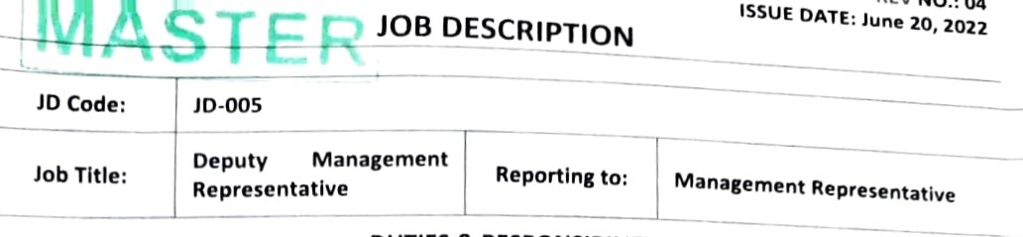
Implement the corrective related to lab within specified time-frame and maintain Corrective Action Log.
Perform training need analysis of the laboratory staff and assist to plan annual training schedule.
Update the training records / Lab Authorization Permit of lab staff on periodic basis.
ensure the proper environmental conditions maintenance in the laboratory.
Ensure that tests are performed as per the STMs
Perform calculations for the uncertainty of a measurement. Ithority
- To stop the activity, if found any non—conformity related to testing, accommodation and environment.
- To raise document change request.
- To investigates the root causes of the problem, corrective action(s) to be taken and indicate the date by which the corrective action will be fully implemented:

CODE OF IMPARTIALITY AND CONFIDENTIALITY NO.: 02
ISSUE 20.2022
- Confidentiality
  - TARA Laboratories is committed to safeguarding the confidentiality of our vendors, suppliers and partners. All information disclosed and indicated as confidential be kept as such. TARA Laboratories will only use this information to facilitate our business transaction, and for communication purposes (email, telephone, etc.) where required.

  - TARA Laboratories will not disclose such information to third parties, unless prior agreement has been provided, from clients, customers and/or other related partie;. Confidential Information refers to all technical and non-technical information, including documentation, drawings, plans, specifications, policies, procedures, operationai and business secrets, customer data, findings and results/reports deriving from tests, method%, formulas; and any other materials provided to TARA Laboratories.
I hereby ensure to follow the guidelines provided in said Code of Conduct and comply in all areas of TARA Laboratories to the best of my knowledge and within my control. If I do not follow the liabilities, company has the right to act for violence and to take any disciplinary and legal action.
Emplo | ee signature
Date

effective professional working environment.
Plan and direct the activities to stated/agreed targets and standards for financial performance, quality culture and legislative adherence.
Identify, develop and direct the implementation of business strategy / mission.
Develop and maintain a professional culture, values and reputation within facility as well as with customers, suppliers and regulatory/official bodies.
Act as the Organization Representative in dealings with the outside world to achieve harmony and business.
Chairs the Management Review Meeting.
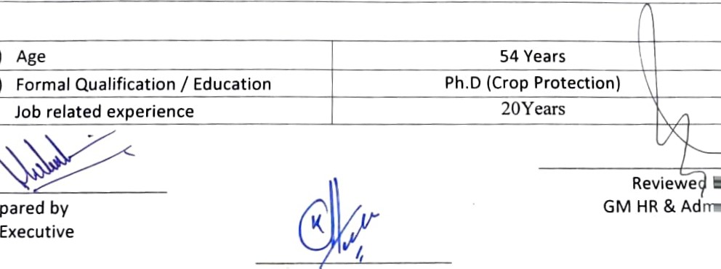
Formulate policies & plans for the laboratory, administration and execution of all the activities of laboratory relating to management & technical operations.
Devise the quality policy and setting out the quality objectives.
Exercise control & authority for the development, implementation and smooth operation of LMS (Laboratory Management System).
Provide overall guidance & adequate resources required for effective implementation of the LMS uthority
- Approve the selected recruitment and develop executive team members.
- Approval of the corporate manufacturing plans along with financial and physical resources.

ISSUE DATE: June 20, 202

POLICY FOR IMPARTIALITY and CONFIDENTIALITY
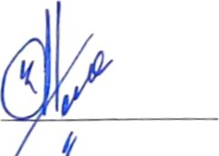
In all our operations (testing and product-certification), Top management of Tara Laboratories is committed to independence and impartiality in our dealings with customers, vendors, suppliers and partners. We maintain a presence of objectivity, independence, neutrality and freedom from conflict of interest. All our personnel are aware of their duties and responsibilities and the requirement for impartiality is to be maintained at all times so as to ensure possible conflicts of interests do not arise.
Chief Executive Officer

CODE OF IMPARTIALITY AND CONFIOENT'AL'T!
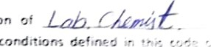
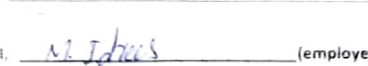position of have read, understand and agree to abide the terms and conduct of Tara Laboratories, Raiwind, Lahore.
defined
(employee)
'n
- Personal and professional behavior are to perform duties associated with ccmcetent and honest manner.
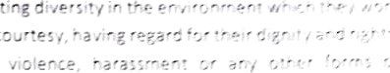
Emo'cvees act fäiriy and equitati'/, resæcting 2nd tc treat a'! ethers with resoect ane Employees dc not engage in Suii','ing. victimization.
Employees dress and act in public in a on the organization or other employees.

Employee's use of social media does not compromise and its allied departments and does not include attacks.
- Accountability
- 1 Employees understand and comply with
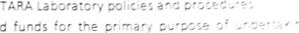
  - Employees use equipment. facilities and funds organizational duties.
for
the

  - Employees maintain confidentiality of all organization during employment and other formal engagement with, information for the purposes of carrying cut duties. Employees are liable for seeking clarification where employment and duties.
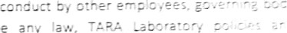
2.5 Employees take responsibility for reporting members or volunteers which contravene any Jaw, procedures, or this Code of impartiality and confidentia:o.
- Conflicts of interest
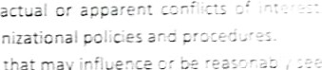
  - Emp!oyees declare and manage any potential, nepotism and patronage in accordance with orzanizaticnai
  - Employees do not accept gifts, benefits or favors that ma; to influence decision making.
- Safe Environment
Employees are to perform their duties in a safe and competent manner ;aborator-v workplace health and safety guidelines.
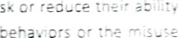
  - Empioyees must take care not to put themseives cr others a: risk cr carry out their duties through unsafe practices, inappropriate 'aboratcry chemicals.
  - Employees take action in identifying, preventing and safety risks.

ISSUE DATE: June 20, 2022

JOB
JD Code: | JD-007
Job Title: | Chemist | Reportlng | Manager Quality Control
to:
DUTIES & RESPONSIBILITY
- Responsible for analysis Of all raw materials, formulations and imported products.
- Responsible to Work for new product development and suitability evaluation through laboratory Trials.
C. Responsible to record the analysis data, statistical analysis in respective registers and also keep record in soft form.
- Responsible to standardize the working standards/chemical solutions.
- Responsible to issue the Recipe and formulation procedure to production department with consultation of Manager Quality Control/Technical Manager.
required |  | MSc. Agriculture/ e istry: Fresh
Pre a ed by | Approv Y | Reviewed by
HR Executive | General Manager | Manager Quality Control
- Responsible of proper handling, storage, and updating the inventory of all chemicals/Apparatus being used in the lab.
- Responsible for internal calibration of equipment.
- Responsible for stability studies of all formulated and packed products and keeping their record.
Responsible for prepare technical reports.
Responsible for issue the quality reports with the approval of QCM/Dy.GM QC.
k. Responsible to perform all the analysis activity pertaining to validation/verification of intended methods
Authority
- To stop the activity, if found any non—conformity related to testing, accommodation and environment.
- To release or reject the raw material and roduct,
SELECTION CRITERIA
- Min. Age 22-28 Years
- Min. Formal Qualification / B.A/BSc. / MSc. Agriculture/Chemistry Education
- Min. Job related experience B.A/BSc. : 5Years,

- Communicate the Management Review Meeting schedule to all participants.
- Record and maintain the minutes of management review meeting and follow up of MRM decisions.
- Implement the corrective related to lab within specified time-frame and maintain Corrective Action Log.
Perform training need analysis of the laboratory staff and assist to plan annual training schedule.
- Update the training records / Lab Authorization Permit of lab staff on periodic basis.
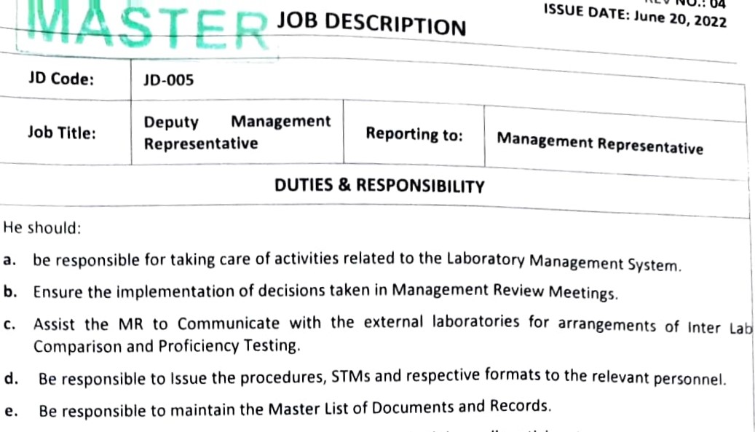
- ensure the proper environmental conditions maintenance in the laboratory.
Ensure that tests are performed as per the STMs
m. Perform calculations for the uncertainty of a measurement.
Authority
  - To stop the activity, if found any non—conformity related to testing, accommodation and environment.
  - To raise document change request.
  - To investigates the root causes of the problem, corrective action(s) to be taken and indicate the date by which the corrective action will be fully implemented:


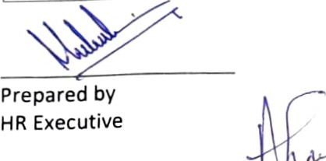
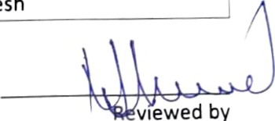
vtewed
by
Manager
Quality
Control
JD Code: | JD-009
Job Title: | Lab Attendant | Reporting to: |  | Manager Quality Control
DUTIES & RESPONSIBILITY
- Collect sample of all pesticide and fertilizer products from warehouse and production department for analysis under the supervision of Lab Assistant/Chemist.
- Washing of all glassware / apparatus used in laboratory.
C. Assists to perform all chemical analysis of pesticide and fertilizer products.
- Assists to develop formulation of new recipes.
- Maintain the laboratory and equipment clean and organized.
SELECTION CRITERIA
a ) Min. Age |  |  | 18-Years
b) Min. Formal Qualification /  Education |  |  | SSC/FA
c) Min. Job related experience required |  |  | Fresh

DUTIES & RESPONSIBILITY
- Responsible to ensure the product quality is complied with government standards.
- Responsible to monitor the test execution as per standard procedures.
- Responsible for quality inspection/testing of all the raw materials received at plant.
- Responsible for quality inspection/testing of all finished products, both for in-house and imported.
- Responsible for generating analysis reports of products and raw materials.
- Responsible for issuance of Batch recipe and formulation procedure to the production department to formulate a new batch and keep record.
- Responsible for the development of quality testing procedures for raw materials and formulated products.
- Responsible for implementation of quality standards and procedures.
Responsible for maintaining reference standards and development of working standards with them.
Responsible for development of product recipes as per requirement.
k. Responsible for carrying out the stability studies.
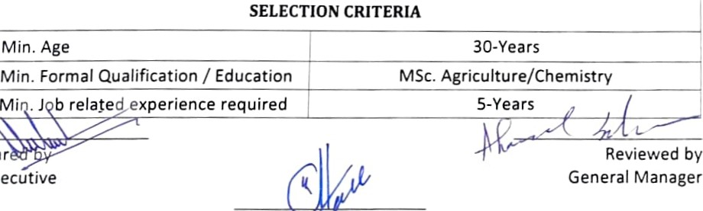
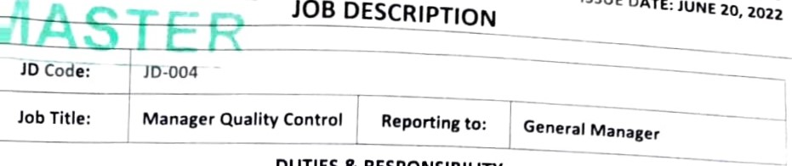
Responsible for planning of daily laboratory functions.
Ap
ovdp
by
CEO
DATE:
JUNE
20,
2022
m. Responsible for inspection of registration data of product on packing material before and after printing.
Responsible to manage laboratory equipment and materials required for analysis.
o. Responsible for laboratory Equipment repair and maintenance work timely.
thority
- To review and authorize the Test Report before issued to the customer.
- To stop the activity, if found any non—conformity related to testing, accommodation and environment.
Reviewed by ecutive General Manager

- REV NO.: 03
ISSUE DATE: June 20, 2022


JOB
JD code:
JD code: | JD-008
Job Title: | Assistant Chemist | Reporting to: | Manager Quality Control
DUTIES & RESPONSIBILITY
He should;
- Assists to perform analysis of all raw material and finished products.
- Prepare the trial samples for research and development.
- Assists in Standardization of working standards with the help of reference standards.
- Be responsible for documentation and record keeping of all quality related and environmental documents.
- Be responsible for handling and storage of all chemicals being used in the lab.
- Assists to perform stability study of new and existing products and keeping record.
- Supervise lab attendants in laboratory.
- Maintain the laboratory and equipment clean, safe and organized.
SELECTION CRITERIA
a) Min. Age |  | 20-22Years
b) Min. Formal Qualification /  Education |  | BA/BSc. Agriculture/Chemistry
c) Min. Job related experience required |  | BA=2-Years / BSc.= Fresh
 |  |  |  |  |  | 
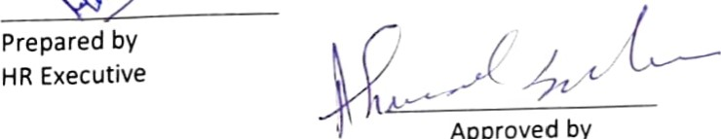
Reviewed by
Approved
by
Manager Quality Control
General Manager

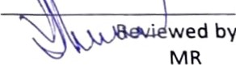
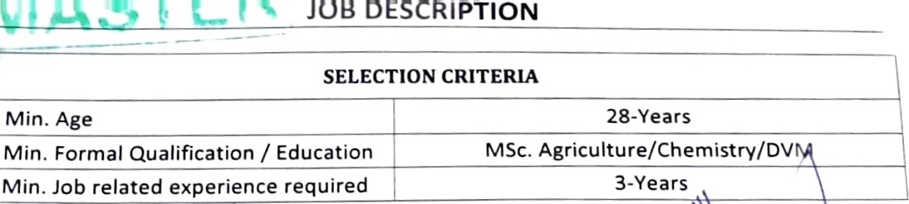
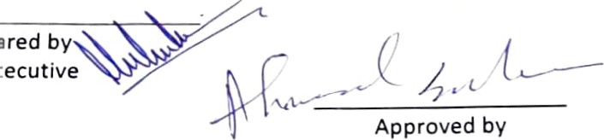
Approved
General Manager

